Unisex Soft Tee $15 XXL…$17 XXXL…$18 XXXXL…$19

Soft, heathered crew neck tee; 90/10 Airlume combed and ring spun cotton/poly. Design will be printed in white ink.

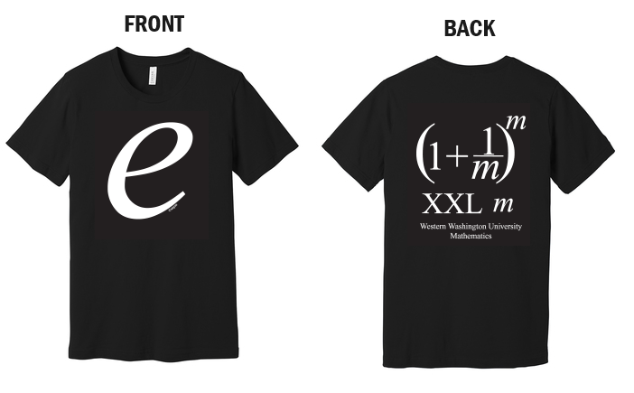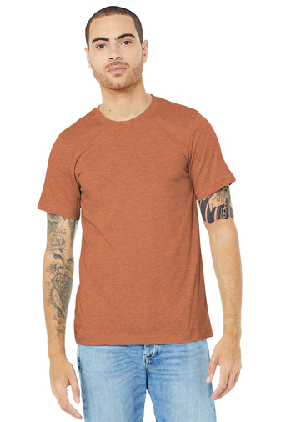

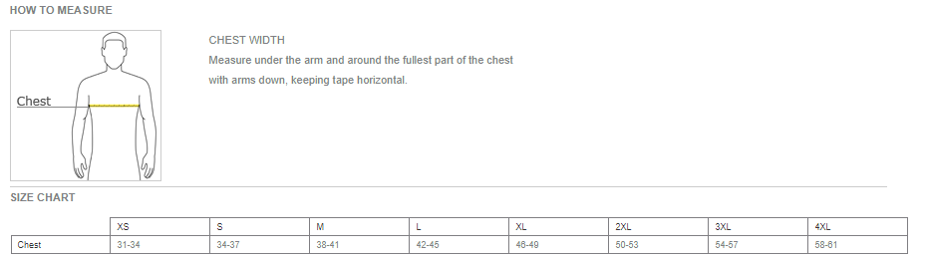

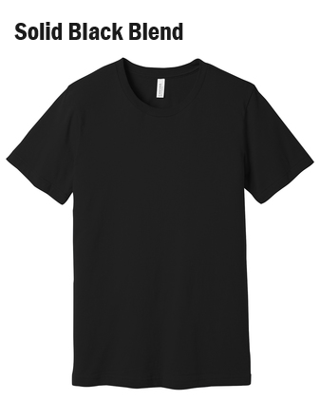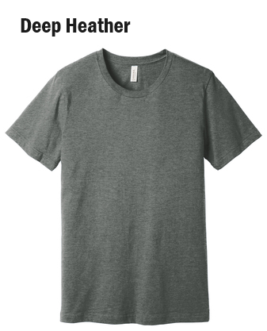

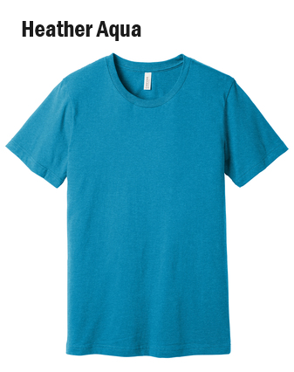

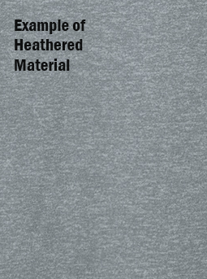

Thank you for supporting WWU Math

Order by MAY 20, 2024!

<https://commerce.cashnet.com/MA1_MathGear>