Unisex Sport-Tek 1/4 Zip Pullover $35
XXL…$37 XXXL…$38 XXXXL…$39
An extremely flexible layer with a soft-brushed backing and moisture control for year-round comfort; 90/10 poly/spandex. Design will be printed in white ink on the front only. 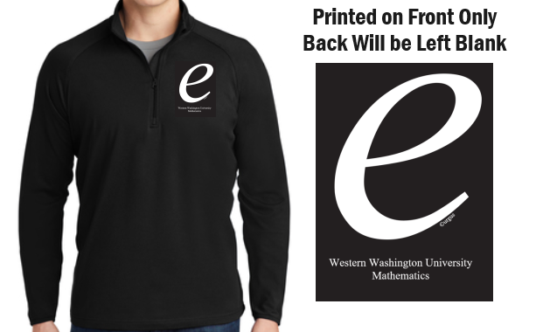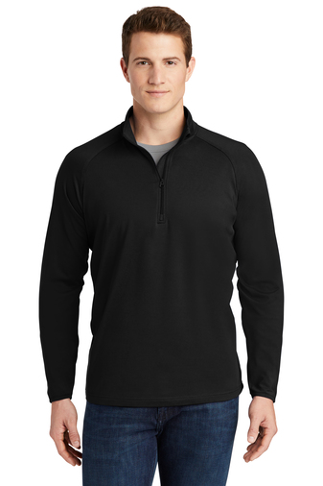
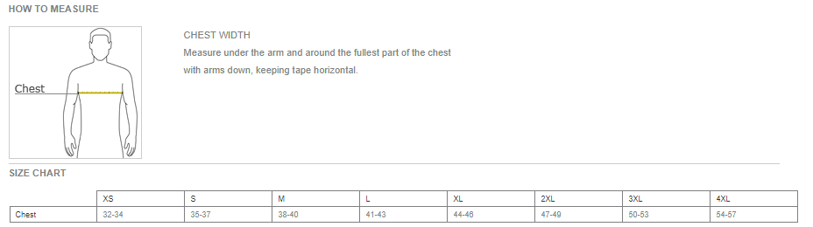
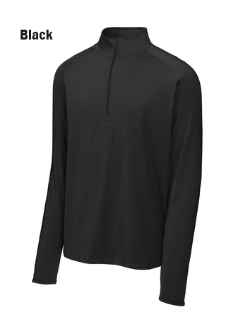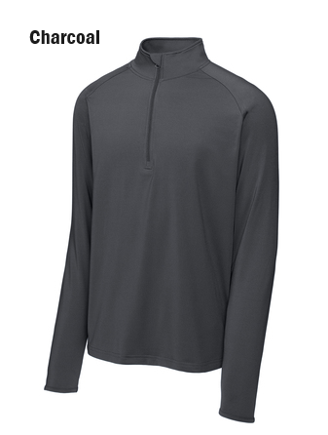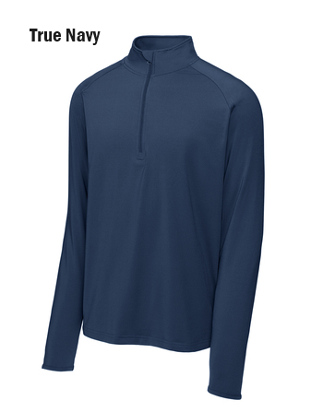
Thank you for supporting WWU Math
Order by MAY 20, 2024!
https://commerce.cashnet.com/MA1_MathGear

